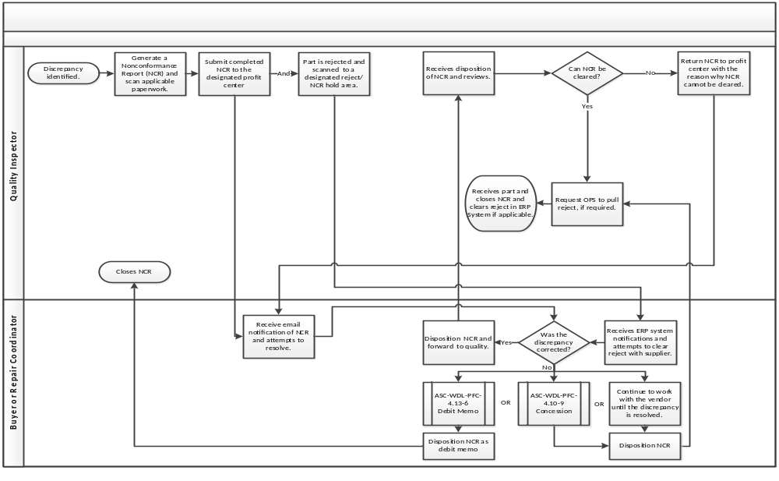
See listing of authorized personnel to provide a Concession Disposition for nonconforming product on MyConnection / Business System Management Documents / AAR Supply Chain, Inc. / Wood Dale / Form: AAR-WDL-0101.

